Buntingford Library Visual Story
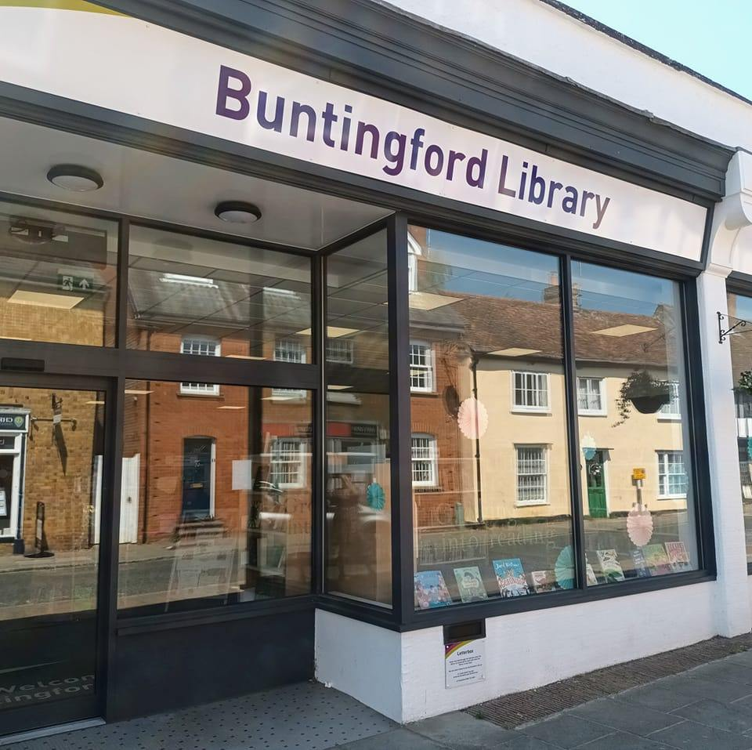
Buntingford Library, 77 High Street, Buntingford, SG9 9AE
Opening Hours:
Monday | 10.00am | - | 5.30pm
Tuesday | 10.00am | - | 5.30pm
Wednesday | Closed
Thursday | 10.00am | - | 5.30pm
Friday | 2.00pm |  | 5.30pm
Saturday | 9.00am | - | •1.00pm
Sunday | Closed

This is a simple guide to help people visiting Buntingford Library for the first time, if you have any questions please ask the staff.
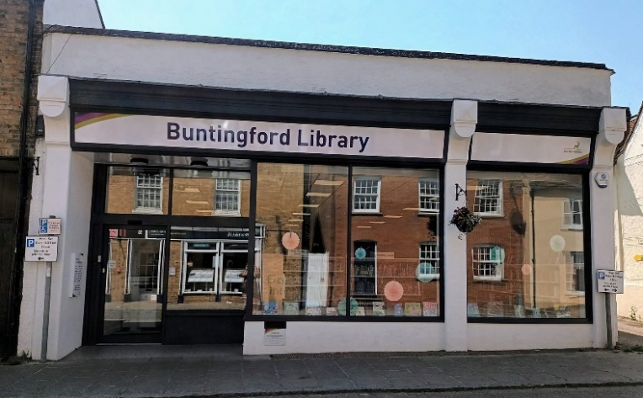 | This is Buntingford Library  
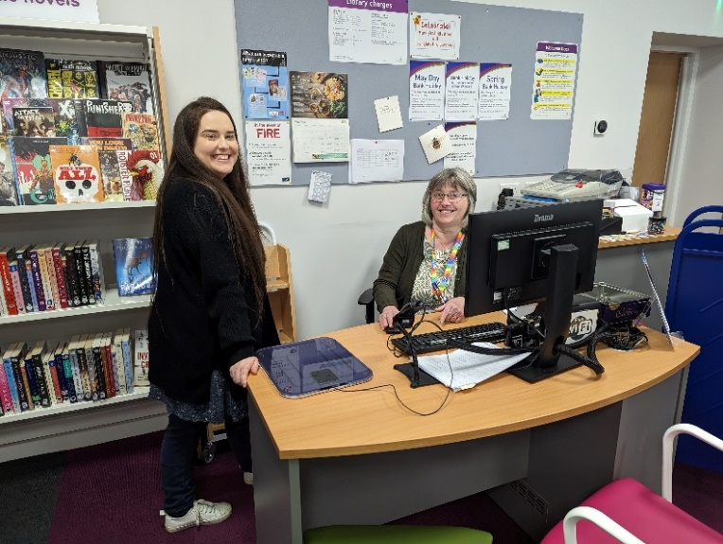 | This is the help desk, please ask for help here.    You may have to wait if we are busy.
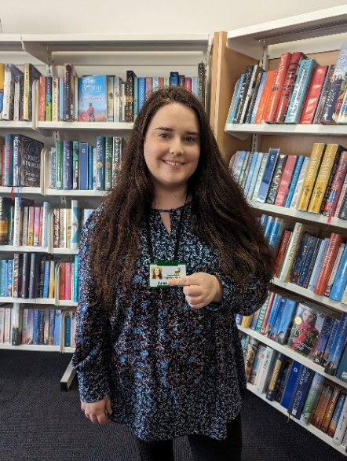 | Library staff are here to help. All library staff wear a badge like this.  
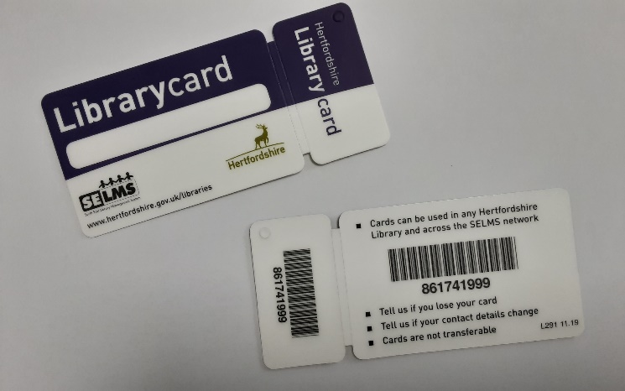 | This is a library card, you will get one when you become a library member.    You need a library card to borrow books and to use the computers.  To get a library card, ask the staff at the help desk.
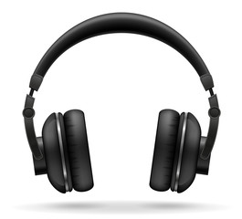 | Sometimes we have noisy times in the library and you may wish to visit at a quieter time.    Or you can bring some ear defenders to wear.
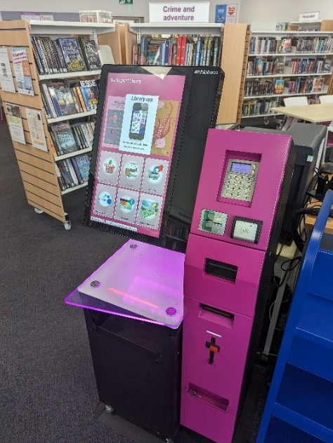 | This is a kiosk. You can borrow and return books here.    Follow the instructions on the screen. Ask the library staff if you need help.  If it is busy you may need to queue.
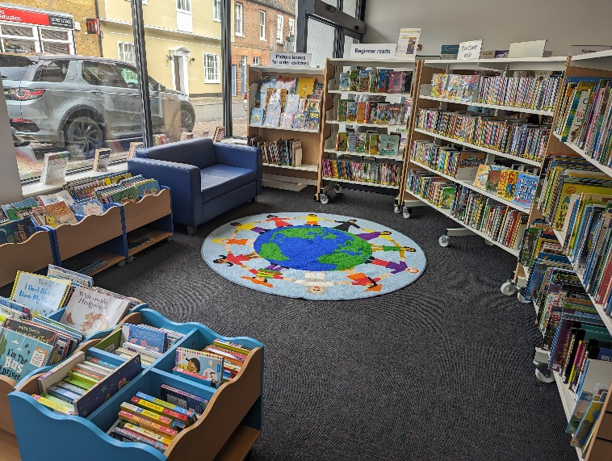 | This is the Childrens’ area.  
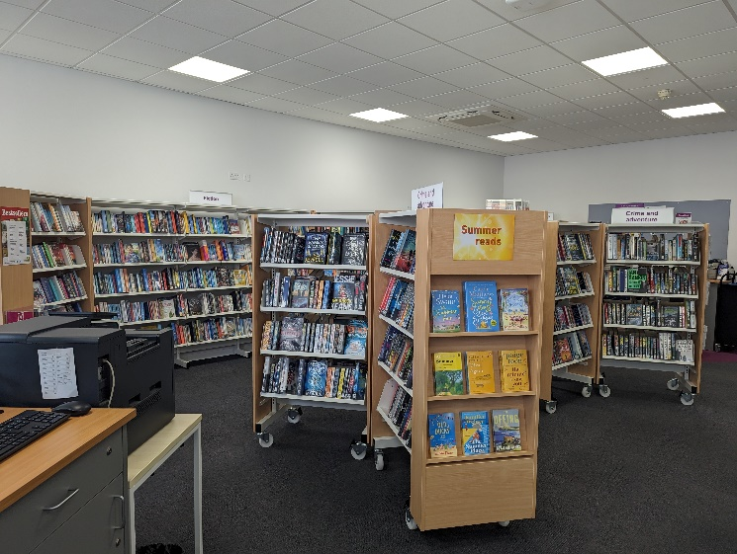 | There are lots of books you can borrow.  
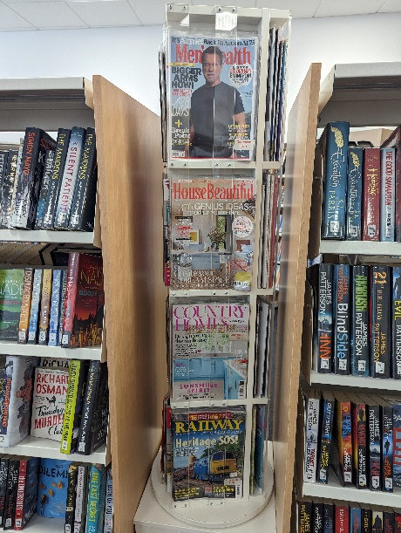 | There are magazines which you can borrow.  
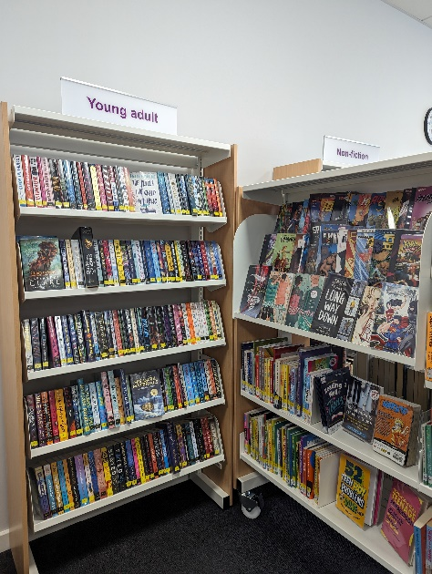 | This is the Young Adult area near the computers.  
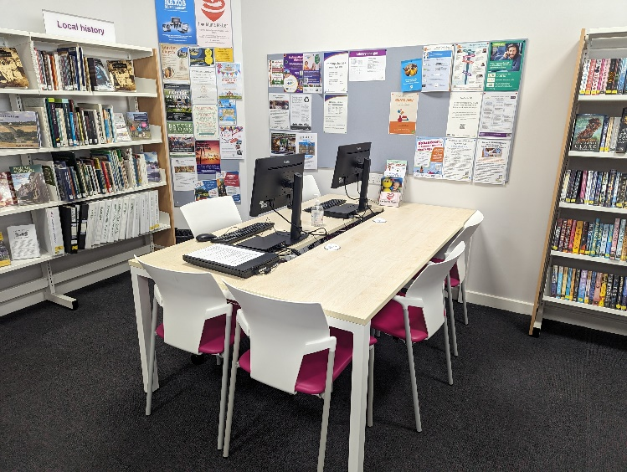 | This is the study area. There is free Wi-Fi in the library.    Ask staff for login details.
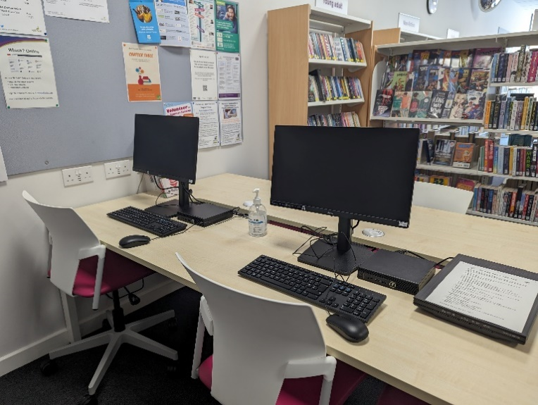 | These are our computers which you can use.    Library members can use them for free for two hours a day.  If the computers are busy you may need to book. Ask the library staff if you need help.
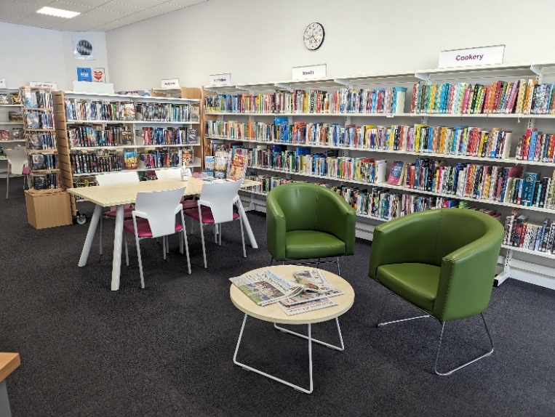 | This is an area to sit and read in.  
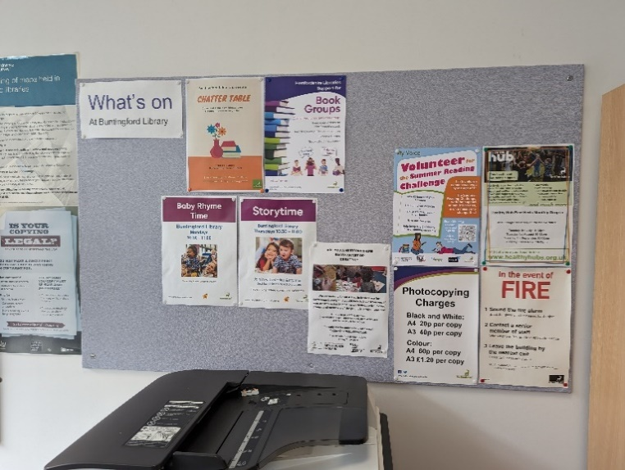 | This is a display board which tells you about events, activities and clubs happening in the library soon.    Ask a member of staff if you would like to know more.
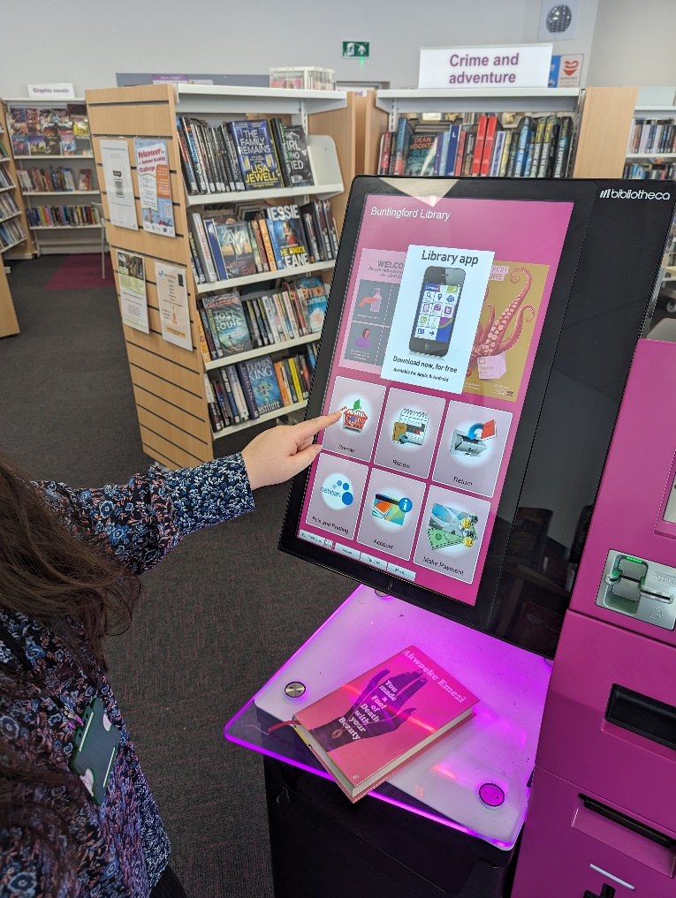 | When you are ready to leave the library, take the things that you want to borrow to the kiosk and follow the instructions on the screen.    Ask the library staff if you need help.  If it is busy you may need to queue.
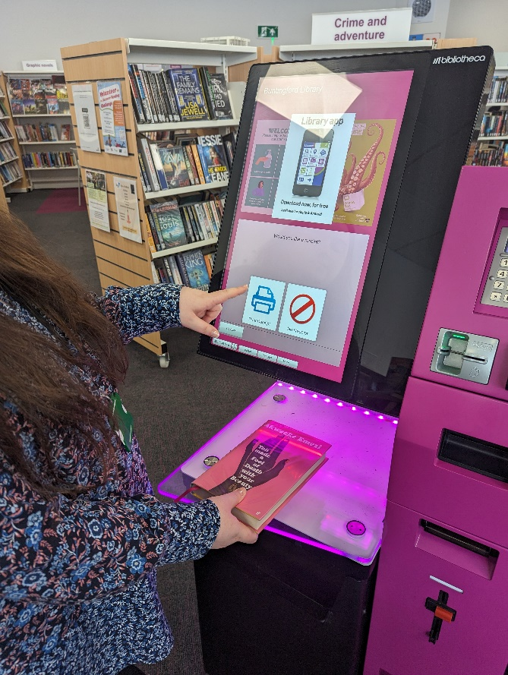 | You can take the things you have borrowed home. Print a receipt so you know when you need to bring them back to the library.    Remember to return or renew your items on time to avoid charges.  You can renew your items at the kiosk or:  - ask at the desk  - online at www.hertfordshire.gov.uk/libraries  - Telephone: 0300 123 4049  - Textphone: 0300 123 4041
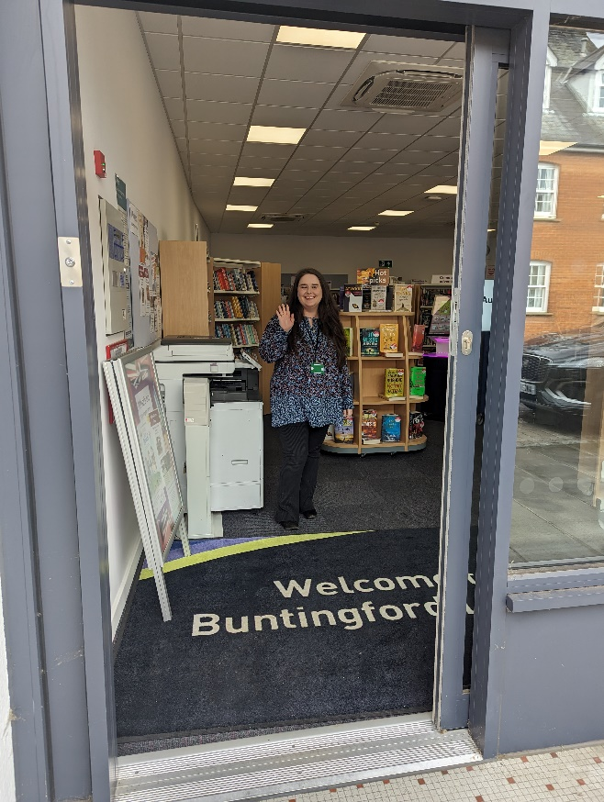 | We hope you enjoyed the story.  If you need any extra help or information please ask a member of staff.     For more information on the library please visit our website:  www.hertfordshire.gov.uk/buntingfordlibrary  Please come back soon.

