**Tring Library Visual Story**

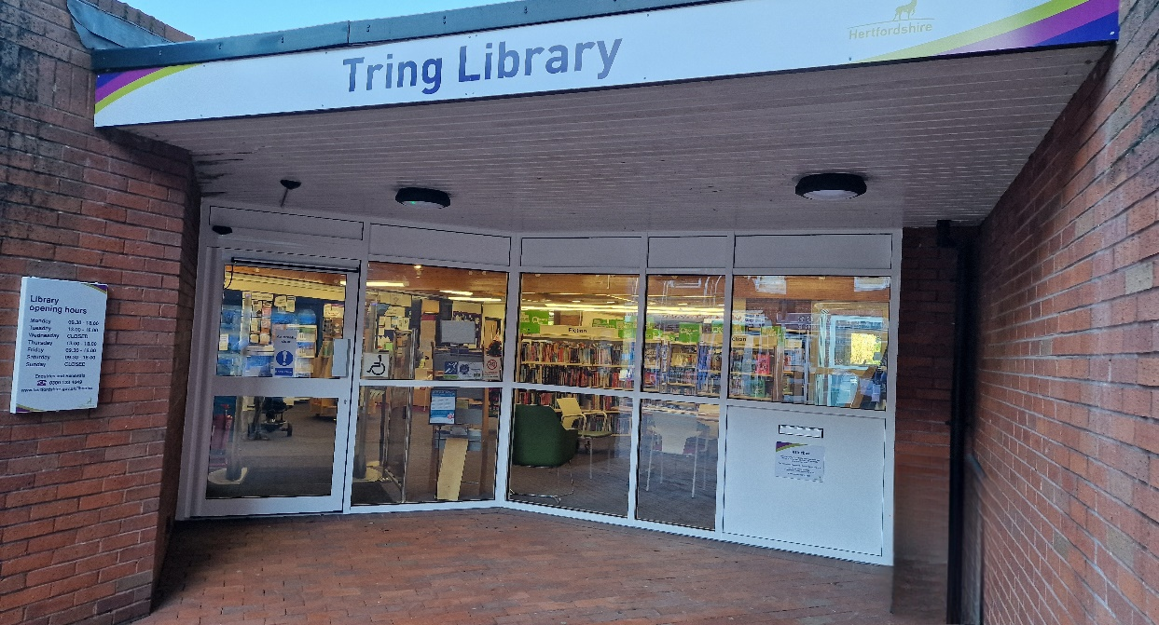

**Tring Library, High Street, Tring,**

**HP23 4AF**

**Opening Hours:**

|  |  |  |  |
| --- | --- | --- | --- |
| **Monday** | 9.30am | - | 6.00pm |
| **Tuesday** | •1.00pm | - | 6.00pm |
| **Wednesday** | Closed |  |  |
| **Thursday** | •1.00pm | - | 6.00pm |
| **Friday** | 9.30am | - | 6.00pm |
| **Saturday** | 9.30am | - | 4.00pm |
| **Sunday** | Closed |  |  |

This is a simple guide to help people visiting Tring Library for the first time, if you have any questions, please ask the staff.

|  |  |
| --- | --- |
| outside vie of the entrance to Tring Library | This is Tring Library   |
| large desk with 2 members of staff working on computers. there are chairs in front of the desk and noticeboards behind. | This is the help desk.    Ask here if you need help or have any questions.  If it is busy you may need to queue. |

|  |  |
| --- | --- |
| member of staff showing her badge | Library staff are here to help.  All library staff wear a badge like this.   |
| **headphones** | Sometimes we have noisy times in the library and you may wish to visit at a quieter time.    Or you can bring with you some ear defenders to wear. |

|  |  |
| --- | --- |
| library cards | This is a library card; you will get one when you become a library member.    You need a library card to borrow books and to use the computers.  To get a library card, ask the staff at the help desk. |
| self service touchscreen kiosk | This is a kiosk. You can borrow and return books here.    Follow the instructions on the screen. Ask the library staff if you need help.  If it is busy you may need to queue. |
| inside children's library with shelves full of books on either side and boxes with picture books in the middle | This is the children’s area.   |
| shelves full of books | There are lots of books you can borrow.   |
| magazines on a shelf | You can also borrow magazines.   |
| inside the library with a table and 3 chairs in the middle and bookshelves in the background | You can read newspapers and Magazines.   |
| toilet sign with male, female, baby change and wheelchair symbols | There is a toilet in the library.    If it is busy and you may need to queue. |
| study area with computers on the right and a table with chairs in the middle. | This is our computer and study area. These are located at the back of the library. Library members can use the computers for free for two hours a day.    If the computers are busy you may need to book.  Ask the library staff if you need help. |
| woman sitting on a pink sofa, reading using a tablet. | There is free Wi-Fi in the library. black and white wifi logo  Ask staff for login details. |
| book in self service kiosk | When you are ready to leave the library, take the things that you want to borrow to the kiosk and follow the instructions on the screen. Ask the library staff if you need help.  If it is busy you may need to queue   |

|  |  |
| --- | --- |
| **touchscreen self service kiosk with receipt coming out** | You can take the things you have borrowed home. Print a receipt so you know when you need to bring them back to the library.    Remember to return or renew your items on time to avoid charges.  You can renew your items at the kiosk or:   * ask at the desk. * online at [www.hertfordshire.gov.uk/libraries](http://www.hertfordshire.gov.uk/libraries) * Telephone: 0300 123 4049 * Textphone: 0300 123 4041 |

|  |  |
| --- | --- |
| hands putting books in a bag next to a self-service kiosk | We hope you enjoyed the story.  If you need any extra help or information please ask a member of staff.     For more information on the library please visit our website:  [www.hertfordshire.gov.uk/tringlibrary](https://www.hertfordshire.gov.uk/tringlibrary)  Please come back soon. 😊 |