**Welwyn Garden City Library Visual Story**

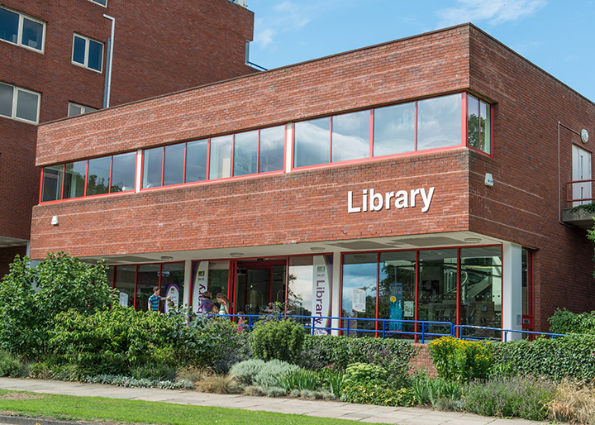

**Welwyn Garden City Library, Campus West,**

**Welwyn Garden City, AL8 6AJ**

**Opening Hours:**

|  |  |  |  |
| --- | --- | --- | --- |
| Monday | 9.00am | - | 7.00pm |
| Tuesday | 9.00am | - | 7.00pm |
| Wednesday | 9.00am | - | 7.00pm |
| Thursday | 9.00am | - | 7.00pm |
| Friday | 9.00am | - | 7.00pm |
| Saturday | 10.00am | - | 5.00pm |
| Sunday | •1.00pm | - | 5.00pm |

This is an easy read guide to help you visit Welwyn Garden City Library for the first time. If you have any questions, you can ask the staff.

|  |  |
| --- | --- |
| A photo of the Welwyn Garden City central library building. | This is Welwyn Garden City Library.   |
| A photo of the automatic doors at the front entrance of the library. | This is the front door of the library.    The heater in here might be noisy. |
| A photo of the back door to the library accessed by a ramp with handrails. | You can also come into the library at the back door.   |
| A woman is sat behind a computer at a desk, smiling and waving. | This is the help desk. Ask here if you need help or have any questions.    If it is busy you might need to queue. |
| The woman is smiling and holding up her identity badge attached to a purple lanyard. | Library staff are here to help you. We all wear a badge like this one.   |
| **A pair of black ear defenders** | Sometimes we have noisy times in the library, like when people are singing. You might want to come when it is quiet.    Or you can bring some ear defenders to wear. |
| A library card showing the front and back, with mini keyring versions next to them. The front has a blank space for a name, and the back has a barcode on. | This is a library card. You will get one when you become a library member.    You need a library card to take books home with you or to use the computers. |
| Library membership forms for an adult and a child. | We can help you write down your name and where you live on one of these forms. We need to know this before we can give you a library card.    Or you can take it home with you and ask your family or support worker to help you. |
| The woman is pulling a book off a shelf. | There are lots of books you can take home with you. You need to bring them back to the library after.    Or you can sit in the library and read them. |
| Open pages of picture books for adults with learning disabilities. | We have books with lots of pictures that are easy to read. They are called **Books for Everyone.**   |
| A display stand of magazines in the library. | You can take magazines home with you.    Or you can read them in the library. |
| A photo of the shelves of talking books. | There are books you can listen to that you can take home with you.   |
| Three books on a table, one about pyramids, one about birds and one about cars. | There are fact books about lots of different things.    Ask the library staff for help and we can find you a book about something you like. |
| The woman is looking in draws full of old photos. | There are lots of old photos and maps of our town.    Ask the staff if you want to look at these. We might even be able to show you what your house used to look like. |
| A photo of the children's area in the library, with sofa, boxes of books and squishy mats on the floor. | This is the children’s area.    There are lots of books you can take home with you.  Or you can read them in the library. |
| Photo of a story book with Makaton signs. | There are some books with Makaton.    We can help you find these books if you need help. |
| open book with very large print text on the left page and a picture of birds on the right page | There are books with big letters and braille.    We can help you find these books if you need help. |
| Photo of the teenage area, with comfy chairs and a table and chairs. | This is the teenage area.   |
| Symbols of female, male, baby change and disabled toilet signs. | There are 2 toilets in the library.    If it is busy you might need to wait. |
| The woman is sat in a big comfy chair, reading a magazine. | There are lots of seats where you can sit and relax.   |
| A photo of the staircase in the middle of the library. | These are the stairs if you want to go to the first floor of the library.   |
| The doors to the lift in the library. | Or you can use the lift.   |
| a woman is sitting at a desk using a computer | These are the computers. You can use them for free for 2 hours every day if you have a disability.    Ask the library staff if you need help. |
| a woman is sitting at a table writing | This is the quiet study area, on the first floor of the library.  wifi logo  There is free Wi-Fi in the library. |
| A photo of the kiosk, with a book inside and a hand pointing to the Borrow button. | This is a kiosk. You can take books home with you if you scan them in this machine.    We can show you how to use the machine and we can help you use it.  Sometimes it is busy and you might need to wait. |
| A photo of a hand reaching for a receipt. It is printing out from the library kiosk. | You can take the things you have borrowed home. Print a receipt so you know when you need to bring them back to the library.    If you haven’t finished your books, you can keep them for longer. We call this renewing your book.  Ask us at the desk for help. Or you can talk to us on the phone.   * Telephone: 0300 123 4049 * Textphone: 0300 123 404 |
| Symbol for remember, a man with a thought bubble. | Remember to bring back or renew your books on time.  You might have to pay some money if you bring them back late. |
| The woman is stood at the front of the library, waving goodbye. | We hope you enjoyed the story.  If you need any help, please ask the staff in the library.  Please come back soon. |